****

July 2011

Thanks and Yee-Haw!

Many thanks to **Bo Bean** for putting on a GREAT match in July and to **Jim Bean** for helping with set-up. Contrary to popular belief, the stages were not all stand and deliver…one even had six – count ’em six – shooting positions! Lots of fast and creative stages. Lots of clean shooters.

*Thanks, Bo!*

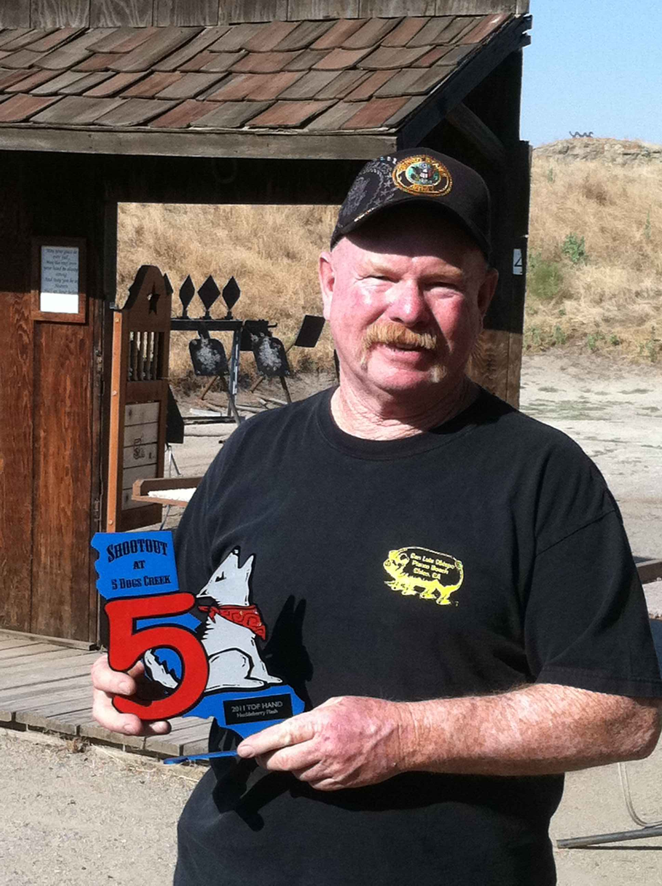

Hearty congratulations to **Huckleberry Flash** who was presented with the 2011 Top Hand Award. Selected by previous Top Hands and the Town Council, this award is given annually to a club member who has gone above and beyond for the club. Huckleberry works hard throughout the year and especially during the Shootout at 5 Dogs Creek. And, he always does it with a big ’ol smile! *Yee-Haw for Huckleberry!*

As the new Town Council takes the leash for the club, please tip your hat and extend thanks to those who have served tirelessly. Taking a break from the Town Council are **Mad Dog Draper** (served two years as mayor), **Mescalero** (served seven years as sheriff), **Hennessey Hayes** (served one year as range wrangler), **Double Shot Darlin’** (served over a year as editor) and **Snakebite** (served as TG extraordinaire for

more than a decade).

*Thanks and Yee-Haw to ya’ll!*

5 Dogs Creek Town Council Elections

Town Council elections were held at the July match. Hats off to those who have stepped forward to help keep things running smoothly…

Mayor –

Sheriff – **Fordyce Beals**

Banker –**Miss Chevious**

Range Wrangler – **Quick Draw Grandpa**

Storekeeper – **El Alacran del Norte**

Blacksmith – **Bones Brannon**

News Editor – **Mad Trapper of Rat River**

Territorial Governor – **Professor Cubby Bear**

You may notice one critical position has not been filled. No one has stepped forward to serve as mayor. While Mad Dog Draper needs a well-deserved break from those responsibilities, he will be on hand to help with the transition of a new mayor. Among other duties as assigned, the position does include leading the committee that plans the annual match and overseeing the non-shooting aspects of that match (not doing it all!). Great systems are in place to help make that happen smoothly. If you want to know more about the role of mayor, contact Mad Dog and he’ll tell ya all about it. ([maddogdraper@roadrunner.com](http://us.mc383.mail.yahoo.com/mc/compose?to=maddogdraper@roadrunner.com" \t "_blank)   805-497-2857)

**Calgary Kate’s soapbox** (that’ll teach Mad Trapper to go on vacation and turn the

keyboard over):

Folks, not having a mayor is a seriously problematic position to be in as a club. If you’ve been following the posts in the past year and again recently on the SASS Wire about Mule Camp, you know that a club with a great reputation that hosted a major regional shoot has folded largely due to lack of membership help. Not just their match folded, but the entire club as a whole. It’s sad to see it happen…and this is not an isolated incident.

Without a mayor, there can be no annual match and the club needs to understand that decision comes with serious ramifications. Without an annual match there will be no funds for range maintenance (never mind anything new), targets or many of the amenities we all enjoy. Our monthly match fees barely cover our monthly expenses. They are not enough to fund new targets, props or major maintenance. And, in my opinion, there’s no “skipping” a year or cutting back on the annual without another set of detrimental ramifications. Other clubs have gone that route and their matches simply never recovered, even a decade later.

If you don’t shoot other places, you may not realize we have one of the nicest ranges in the country. No exaggeration. However, running a club and hosting shooting events, including monthly matches, requires a commitment by many to avoid burning out a few. We are an all-volunteer club, and a small one at that. We all want to have fun, but to keep things operational it requires every one of us to pitch-in all year long.

If you love shooting at 5 Dogs Creek – the monthly matches, the props, the targets, the facilities, the range, the scoring, the annual – it’s time to ask yourself if you can do more to contribute to keeping your club one of the best around. The alternative is not a pleasant thought.

*OK, I’m done – for now.*

Chorro Valley Shootout

If you’ve never had a chance to experience the fun of shooting at another club or have never made it over to our sister club on the coast, now’s the time. The annual Chorro Valley Shootout is coming up August 11-14. Get out of the heat, head to the coast and join your pards for one of the best matches around. *Sign up now!*

Details: <http://chorrovalleyregulators.org/>

Range to-do list

* If you happen to be at the range with five minutes to spare, take along a square-point shovel and knock-down a few of the puncture vines. You don’t have a rake ‘em up….just push them off their tap root and they’ll wither away like the wicked witch. Don’t try to do ’em all. Many hands make light work. Literally just spend five to 10 minutes, if you can.
* If you have a few more minutes and some loppers, the trees at the far end of the range need a little trimming on the bottom branches. Even cutting just a few branches will help. Please pile any cut branches outside the range fence to be picked up.
* Quick Draw Grandpa needs some help cutting new carpets for the loading/unloading tables. Let him know when you’re available to help. (ford514@sbcglobal.net)

